DELETION MUTATION
A deletion mutation occurs when part of a DNA molecule is not copied during DNA replication. This uncopied part can be as small as a single nucleotide or as much as an entire chromosome. The loss of this DNA during replication can lead to a genetic disease.
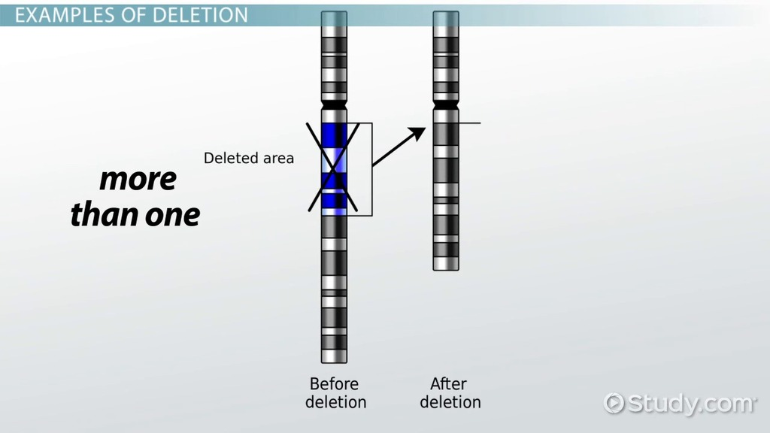

Cystic fibrosis is caused by a deletion mutation. The deletion affects the protein that moves water and salt in and out of cells. It tends to result in mucus building up in different parts of the body. The respiratory and digestive systems are usually the most affected. Many people with cystic fibrosis die in their 30s.
Turner syndrome (TS) is a medical disorder, caused by a deletion that affects about 1 in every 2,500 girls. Most girls are born with two X chromosomes, but girls with Turner syndrome are born with only one X chromosome or they are missing part of one X chromosome. Girls with Turner syndrome are usually short in height. Those who aren't treated for short stature reach an average height of about 4 feet 7 inches. Turner syndrome prevents the ovaries from developing properly, which affects a girl's sexual development and the ability to have children. Because the ovaries are responsible for making the hormones that control breast growth and menstruation, most girls with Turner syndrome will not go through all of the changes associated with puberty unless they get treatment for the condition. Nearly all girls with Turner syndrome will be infertile, or unable to become pregnant on their own.
INVERSION MUTATION

An inversion mutation happens when a section of DNA breaks away and reattaches to the chromosome in a reversed order. This can be a small section of DNA that breaks away or a large section containing many different genes.
Inversions usually do not cause any abnormalities in carriers as long as the rearrangement is balanced with no extra or missing DNA. However, in individuals which are heterozygous for an inversion, there is an increased production of abnormal chromatids (this occurs when crossing-over occurs within the span of the inversion). This leads to lowered fertility due to production of unbalanced gametes.
The most common inversion seen in humans is on chromosome 9. This inversion is generally considered to have no harmful effects, but there is some suspicion it could lead to an increased risk for miscarriage or infertility for some affected individuals. An inversion does not involve a loss of genetic information, but simply rearranges the linear gene sequence.

DUPLICATION MUTATION
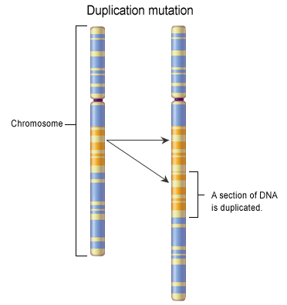
Duplication mutations occur when a portion of a genetic material or a chromosome is duplicated, resulting in multiple copies of that region.
Duplications of certain genes are a common cause of many types of cancer. In such cases the genetic duplication occurs in a somatic (body) cell and affects only the genome of the cancer cells themselves, and is not passed on to offspring.
Gene duplication is believed to play a major role in evolution. Gene duplications are an essential source of evolutionary innovation. Because duplication creates two copies of the same gene, one of those copies is free to develop a new and different function, as the original copy of the gene is still responsible for doing its job. Essentially, one copy is doing all the work, and the other one is free to play around and evolve into something else!

TRANSLOCATION MUTATION
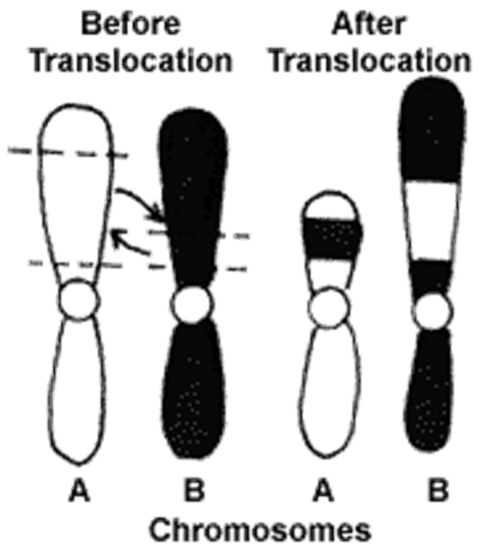
Chromosome translocation is a chromosome abnormality caused by rearrangement of parts between non-homologous chromosomes. For example, a section of a Chromosome 4 might swap genes with a section of Chromosome 20. Or a section of the Y chromosome might swap with a section of the X chromosome.
XX male syndrome is a rare sex chromosomal disorder. Usually, it is caused by a translocation mutation during meiosis in the father, which results in the X chromosome containing the normally-male SRY gene. The SRY gene, normally found on the Y chromosome, is responsible for starting the male sex determination in a zygote. When this X combines with a normal X from the mother during fertilization, the result is an XX male.
Symptoms usually include small testes and subjects are invariably sterile. Individuals with this condition sometimes have feminine characteristics, although most XX males are not stereotypically feminine and are typical boys and men. Reports suggest that facial hair growth is usually poor and libido is diminished

NON DISJUNCTION MUTATION
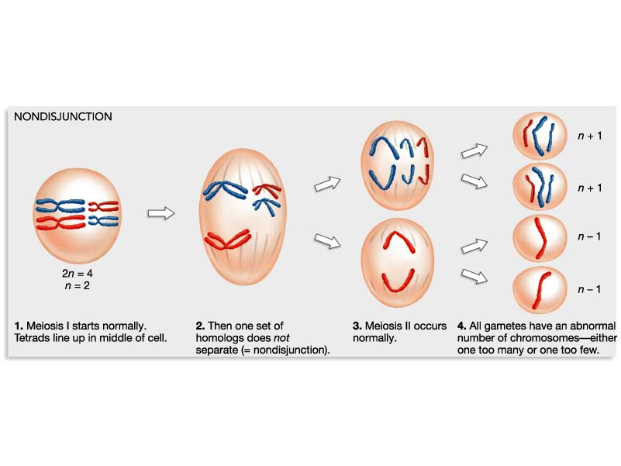
Nondisjunction is the failure of homologous chromosomes to separate properly during cell division. Nondisjunction results in daughter cells with abnormal chromosome numbers. Where a normal cell should have 23 pairs of chromosomes for a total of 46, nondisjunction mutations might result in cells with too many or too few chromosomes.
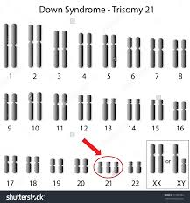
Down syndrome is the most common example of a chromosomal non-disjunction disease. It is caused by a trisomy of chromosome 21 (three copies of chromosome 21), It is well documented that advanced maternal age is associated with greater risk of nondisjunction leading to Down syndrome.
About half of babies with Down syndrome are born with heart defects. Usually, these problems can be corrected by surgery. Kids with Down syndrome are more likely to get infections that affect their lungs and breathing. When they do get infections, they often last longer. They may have eye or ear problems or digestion problems like constipation. Some may develop leukemia, a type of cancer. Each person with Down syndrome is different and may have one, several, or all of these problems.

