Punnett Square Practice Worksheet Name:

1) For each of the genotypes (AA, Aa or aa) below determine what the phenotype would be.

Purple flowers are dominant to white flowers.

PP_____________ Pp____________ pp_______________

Hairy knuckles are dominant to non-hairy knuckles in humans.

HH_____________ Hh ___________ hh _________________

**Bobtails in cats are recessive**. Normal tails are dominant.

TT _____________ Tt _________ tt _____________

Round seeds are dominant to wrinkled seeds in pea plants.

RR______________ Rr _____________ rr ____________

No-cleft chin is dominant. Cleft chin is recessive.

CC ___________ Cc __________ cc _____________

2) For each of the following write whether it is homozygous dominant, heterozygous or homozygous recessive.

AA Ff Aa gg

GG Pp Ii tt

TT Tt aa Oo

Use the following information for questions 3-5:

In dogs, the gene for fur color has two alleles. The dominant allele (F) codes for grey fur and the recessive allele (f) codes for black fur.

3) The female dog is heterozygous. The male dog is homozygous recessive. Figure out the phenotypes and genotypes of their possible puppies by using a Punnett Square.

Genotypes: Phenotypes:

FF: Ff: ff: Black fur: Grey fur:

4) The female dog has black fur. The male dog has black fur. Figure out the phenotypes and genotypes of their possible puppies by using a Punnett Square.

Genotypes: Phenotypes:

FF: Black fur:

Ff: Grey fur:

ff:

5) The female dog is heterozygous. The male dog is heterozygous. Figure out the phenotypes and genotypes of their possible puppies by using a Punnett Square.

Genotypes: Phenotypes:

FF: Black fur:

Ff: Grey fur:

ff:

Use the following information for questions 6-8:

In fruit flies, red eyes are dominant (E). White eyes are recessive (e).

6) If the female fly has white eyes and the male fly has homozygous dominant red eyes, what are the possible phenotypes and genotypes of their offspring?

Genotypes: Phenotypes:

EE: Red Eyes:

Ee:

ee: White Eyes:

7) If the female fly has EE and the male fly has EE, what are the possible phenotypes and genotypes of their offspring?

Genotypes: Phenotypes:

EE: Red Eyes:

Ee:

ee: White Eyes:

8) If both flies are heterozygous, then what are the possible phenotypes and genotypes of their offspring?

Genotypes: Phenotypes:

EE: Red Eyes:

Ee:

ee: White Eyes:

Use the following for questions 9-11:

In dogs, there is an hereditary deafness caused by a recessive gene, “d.” A kennel owner has a male dog (Gilbert) that she wants to use for breeding purposes if possible. The dog can hear.

9) What are the two possible genotypes of Gilbert?

10) If the dog’s genotype is Dd, the owner does not wish to use him for breeding so that the deafness gene will not be passed on. This can be tested by breeding the dog to a deaf female (dd). Draw two Punnett squares to illustrate these two possible crosses.

11) In each case, what percentage/how many of the offspring would be expected to be hearing? deaf? How could you tell the genotype of this male dog? Also, using Punnett square(s), show how two hearing dogs could produce deaf offspring.

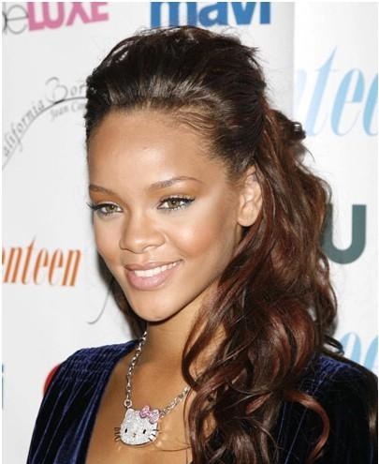Use the following for questions 12-13:

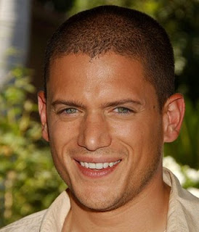Having a widow’s peak like Wentworth Miller is dominant.

Not having a widow’s peak, like Rihanna, is recessive.

12) If Wentworth Miller is Aa, and he and Rihanna had children, what are the possible phenotypes and genotypes of their children?