PARTS OF A MICROSCOPE

Eyepiece or ocular lens: Eyepiece is the lens, present at the top and is used to see the objects under study. Eyepiece lens contains a magnification of 10X or 15X.

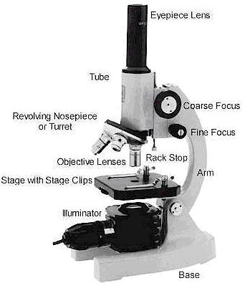
Objective lenses: Generally, three or four objective lenses are found on a microscope, with ranges of 10X, 40X, 100X powers. Lenses are colour coded, the shortest lens is of the lowest power, and the longest lens is high power lenses.

Diaphragm: Diaphragm helps in controlling the amount of light that is passing through the opening of the stage. It is helpful in the adjustment of the control of light that enters.

Coarse adjustment knob: Used for focus on scanning. Usually the low power lens is used enabling the movement of the tube.

Fine adjustment knob: Used for focus on oil. Moves the body tube for focusing the high power lens.

Arm: It supports the tube of the microscope and connects to the base of the microscope.

Stage: The platform that is flat used for placing the slides under observation.

Diaphragm: Diaphragm helps in controlling the amount of light that is passing through the opening of the stage. It is helpful in the adjustment of the control of light that enters

Illuminator: The illuminator provides the light that will allow the viewer to see what is on the slide.

Base: Provides basal support for the microscope.
General care of you microscopes
- Always carry with two hands, one on the base and one on the arm
- Don’t leave the microscope near the edge of the table
- Be careful with the plug and power cord not to get tripped up in them.

How to Focus Your Microscope:
- Start with the lowest power objective lens first
  - Using coarse adjustment knob, bring the stage as close as possible to the lens, without touching it.
  - Now, look through the eyepiece lens and focus upward only until the image is sharp.
  - If you can’t get it in focus, repeat the process again.
- Once the image is sharp with the low power lens, click in the next power lens and do minor adjustments with the fine adjustment knob.
- Continue with subsequent objective lenses and fine focus each time.
- Try to keep both eyes open. This takes some practice and avoids eye fatigue.
- Be careful not to move the stage too high or you might crack the slide.

Making a wet-mount slide
- Place a drop of water on the centre of the slide
- Place your specimen in this drop
- Hold at cover slip at a 45degree angle to the slide and gently lower the cover slip onto the slide. There should be no air bubbles under the cover slip.
- Place your slide on the stage of the microscope.
- When finished, remove the cover slip and clean both the slide and cover slip

How To Stain a Slide:
- Place one drop of stain (Methylene Blue or Iodine) on one edge of the coverslip.
- Place a piece of paper towel against the opposite side of your cover slip, right up against the edge. This will help draw the stain under the cover and across the specimen.
- As soon as the stain has covered the area containing the specimen you are finished. The stain does not need to be under the entire coverslip. If the stain does not cover the area needed, get a new piece of paper towel and add more stain until it does.
- Be sure to wipe off the excess stain with a paper towel, so you don’t end up staining the objective lenses.
- You are now ready to place the slide on the microscope stage.
- Wash and dry both the slide and the coverslip and return them to the correct places!

